Objective: To reinforce forklift safety rules related to operation

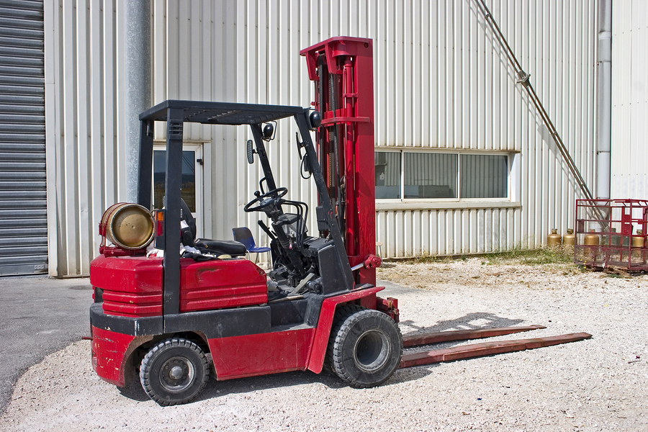
Forklifts are commonly used in numerous work settings, primarily to move materials. A forklift operator must be knowledgeable and committed to safety rules and policies to keep the workplace safe.

Safety rules are an important part of workplace efficiency. This is especially true for lift truck operators due to the potential for property damage, injury, and even death.

During operation:
- All of the manufacturer’s user instructions are to be strictly followed.
- Always wear a safety belt.
- Wear hard hat, safety glasses, and safety shoes as required.
- Loads must be down while the forklift is in motion.
- Tilt the mast back slightly before traveling.
- In general, observe all usual traffic rules and regulations, e.g., keep to the right on roadways and wide aisles and stop at all stop signs.
- Stop at blind spots, and use the horn before moving.
- Give pedestrians the right of way, and assume they do not see you.
- Be alert for wet, slippery, or uneven surfaces while driving.
- Drive at a safe speed, depending on location, presence of pedestrians and condition of surface.
- Follow set speed limits.
- Maintain an indoor speed under 2 mph and an outdoor speed under 15 mph.
- Reduce speed when making turns, when going up or down ramps, at intersections, at corners, at ramps, and at other danger points.
- Assure that there is adequate space:
- Assure clearance before passing under or between structures.
- Maintain a safe distance from hazards, such as power lines or unstable ground.
- Leave adequate space between trucks (i.e., three truck lengths, minimum).
- When turning, give the forklift sufficient room; the back will swing out.
- When driving in reverse (due to forward vision being obscured):
- Reduce the size of the load so the lift can be driven forward without an obscured view.
- Always have a backup alarm.
- Use the horn prior to reversing the lift.
- When parking:
- Do not block traffic, exits, or safety equipment, e.g., fire extinguishers.
- Park with forks on the floor.
- Turn off the power and secure the key.
- Report all accidents and near misses immediately.

Things that should never be done when operating a forklift:
- Never operate a forklift without training and certification. Only company-certified operators are allowed to operate the equipment.
- Never exceed the forklift’s rated capacity or speed. Do not ignore any safety recommendations or restrictions in order to finish a job more quickly.
- Never drive with loads elevated.
- Never ride on or under the load.
- Never let anyone other than the driver ride the forklift.
- Never make turns on ramps.
- Never operate a forklift outside designated areas.
- Never leave an elevated load unattended.
- Horseplay is strictly prohibited.
This form documents that the training specified above was presented to the listed participants. By signing below, each participant acknowledges receiving this training.

Organization: Date: ________________________

Trainer: Trainer’s Signature: _____

Class Participants:

Name: ____ _______ Signature: ___________
Name: ____ _______ Signature: ___________
Name: ____ _______ Signature: ___________
Name: ____ _______ Signature: ___________
Name: ____ _______ Signature: ___________
Name: ____ _______ Signature: ___________
Name: ____ _______ Signature: ___________
Name: ____ _______ Signature: ___________
Name: ____ _______ Signature: ___________
Name: ____ _______ Signature: ___________
Name: ____ _______ Signature: ___________
Name: ____ _______ Signature: ___________
Name: ____ _______ Signature: ___________
Name: ____ _______ Signature: ___________
Name: ____ _______ Signature: ___________
Name: ____ _______ Signature: ___________

